* Start by sharing the story if you have a copy of the book. 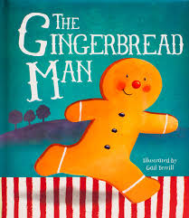

You could also watch and listen to the story by following this link: <https://oldhamtheatreworkshop.co.uk/story-festival/>

* Look at the front cover of the book. Talk to your child about what they can see and what they think might happen in the story.
* Read the story to your child **or** look at the pictures with them and talk about what is happening.
* Can your child finish the repeated rhyme? E.g. Run, run, as fast as you can, you can’t catch me, I’m……………
* Cut out the **puppets below** and stick them onto lolly sticks or straws. Use them to retell the story with your child. Can they remember in which order they met all the characters?
* Cut out the words at the top of the **sentence sheets** attached below. Mix up the words and show your child how to rearrange them to make a sentence to match the picture. Ask your child to use the sounds at the beginning of the words to help them. Point out that we need to start each sentence with a capital letter and finish it with a full stop. Does the sentence make sense? Can your child write out the sentence on the lines below the picture?
* Cut out the numbered gingerbread people attached. Ask your child to find a selection of different numbers. Can they recognise the number and name it? <http://resources.sparkleboxres.co.uk/sb3509.pdf>
* Mix up the numbered gingerbread people. Can your child put them in the right order, starting with zero?
* Ask your child to match a numbered gingerbread person to the same number of objects. For example – Adult “Find number 4. Now find 4 pasta shapes/buttons/crayons, etc. and match them to that number.”

**Puppets** 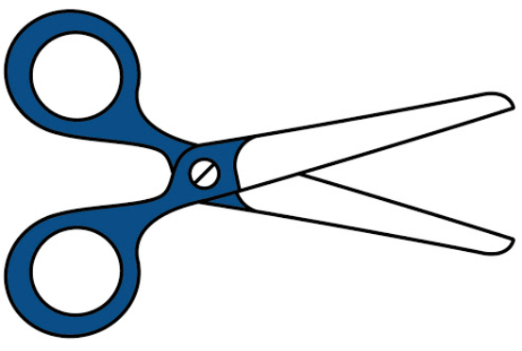

|  |  |
| --- | --- |
|  |  |
|  |  |
|  |  |

**Sentence Sheets**

|  |  |
| --- | --- |
| **fox.** | **The** |

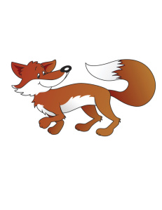

-

|  |  |
| --- | --- |
| **cow.** | **The** |

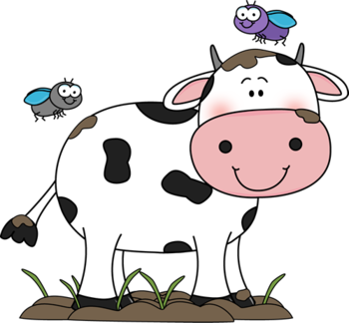

**_____________________________________________**

|  |  |
| --- | --- |
| **run.** | **can** |
| **The** | **cow** |

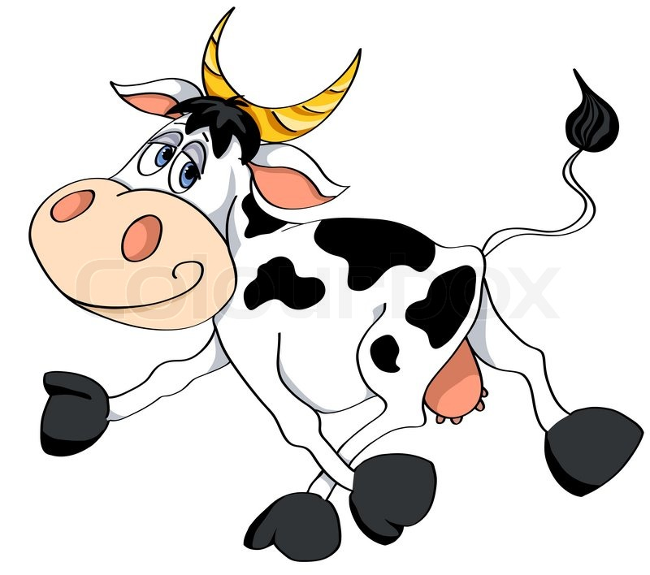

-

|  |  |
| --- | --- |
| **swim.** | **can** |
| **The** | **fox** |



-

|  |  |
| --- | --- |
| **went** | **the** |
| **Snap** | **fox.** |

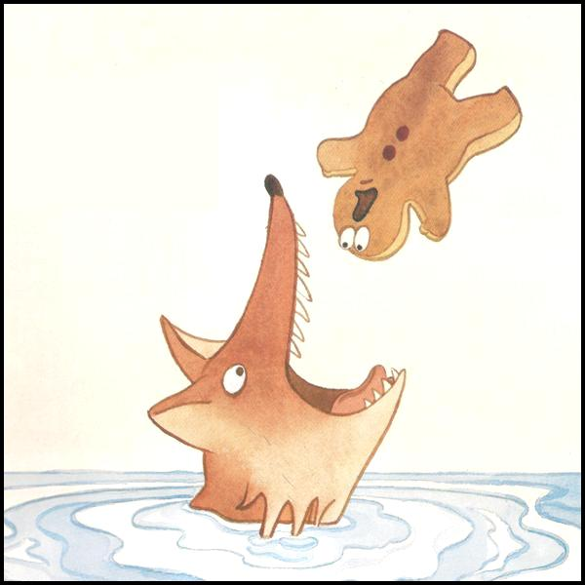

-**Gingerbread People 0 to 10** 

|  |  |
| --- | --- |
|  |  |
|  |  |
|  |  |